Чёрный Алексей Владимирович БПИ-239-2

ИДЗ-3

Вариант 24

Условие:

Разработать программу, которая ищет в ASCII–строке заданную подстроку и возвращает список индексов первого символа для всех вхождений подстроки в строке. Подстрока вводится как параметр. Вывод результатов организовать в файл (используя соответствующие преобразования чисел в строки).

Тесты:

В качестве входного файла я использовал путь к файлу test.txt, который не находится в той же директории, что и программа. В случае отсутствия файла по заданной пользователем директории программа завершается, объясняя пользователю причину ошибки в консоли (не аварийное завершение). Для удобного тестирования файл test.txt имеет такое же содержание, как и test1.txt.  
  
В качестве строки-параметра я использовал слово “igla”, по аналогии с поиском иглы (подстроки) в стоге сена. Поэтому в некоторых файлах используются слова “stog” и “igla”. Такие данные также помогают корректно протестировать работу программы, так как у этих слов есть общая буква “g”. Однако можно использовать другие слова или буквы в качестве параметра.

Тестируемые файлы:

**test.txt:**  
igstogiglaigla  
  
**test1.txt:**  
igstogiglaigla

**test2.txt:**  
stogstogstogstogstogiglstogigla

**test3.txt:**  
igla

**test4.txt:**  
abobaqwertyfloppaabcdefgxyzw ;adfbadiglfbkjiglab

**test5.txt:**  
stog  
  
**test6.txt:**

Тест1:

Ввод:  
Несуществующий путь  
Вывод:  
"Incorrect path or path does not exist!"

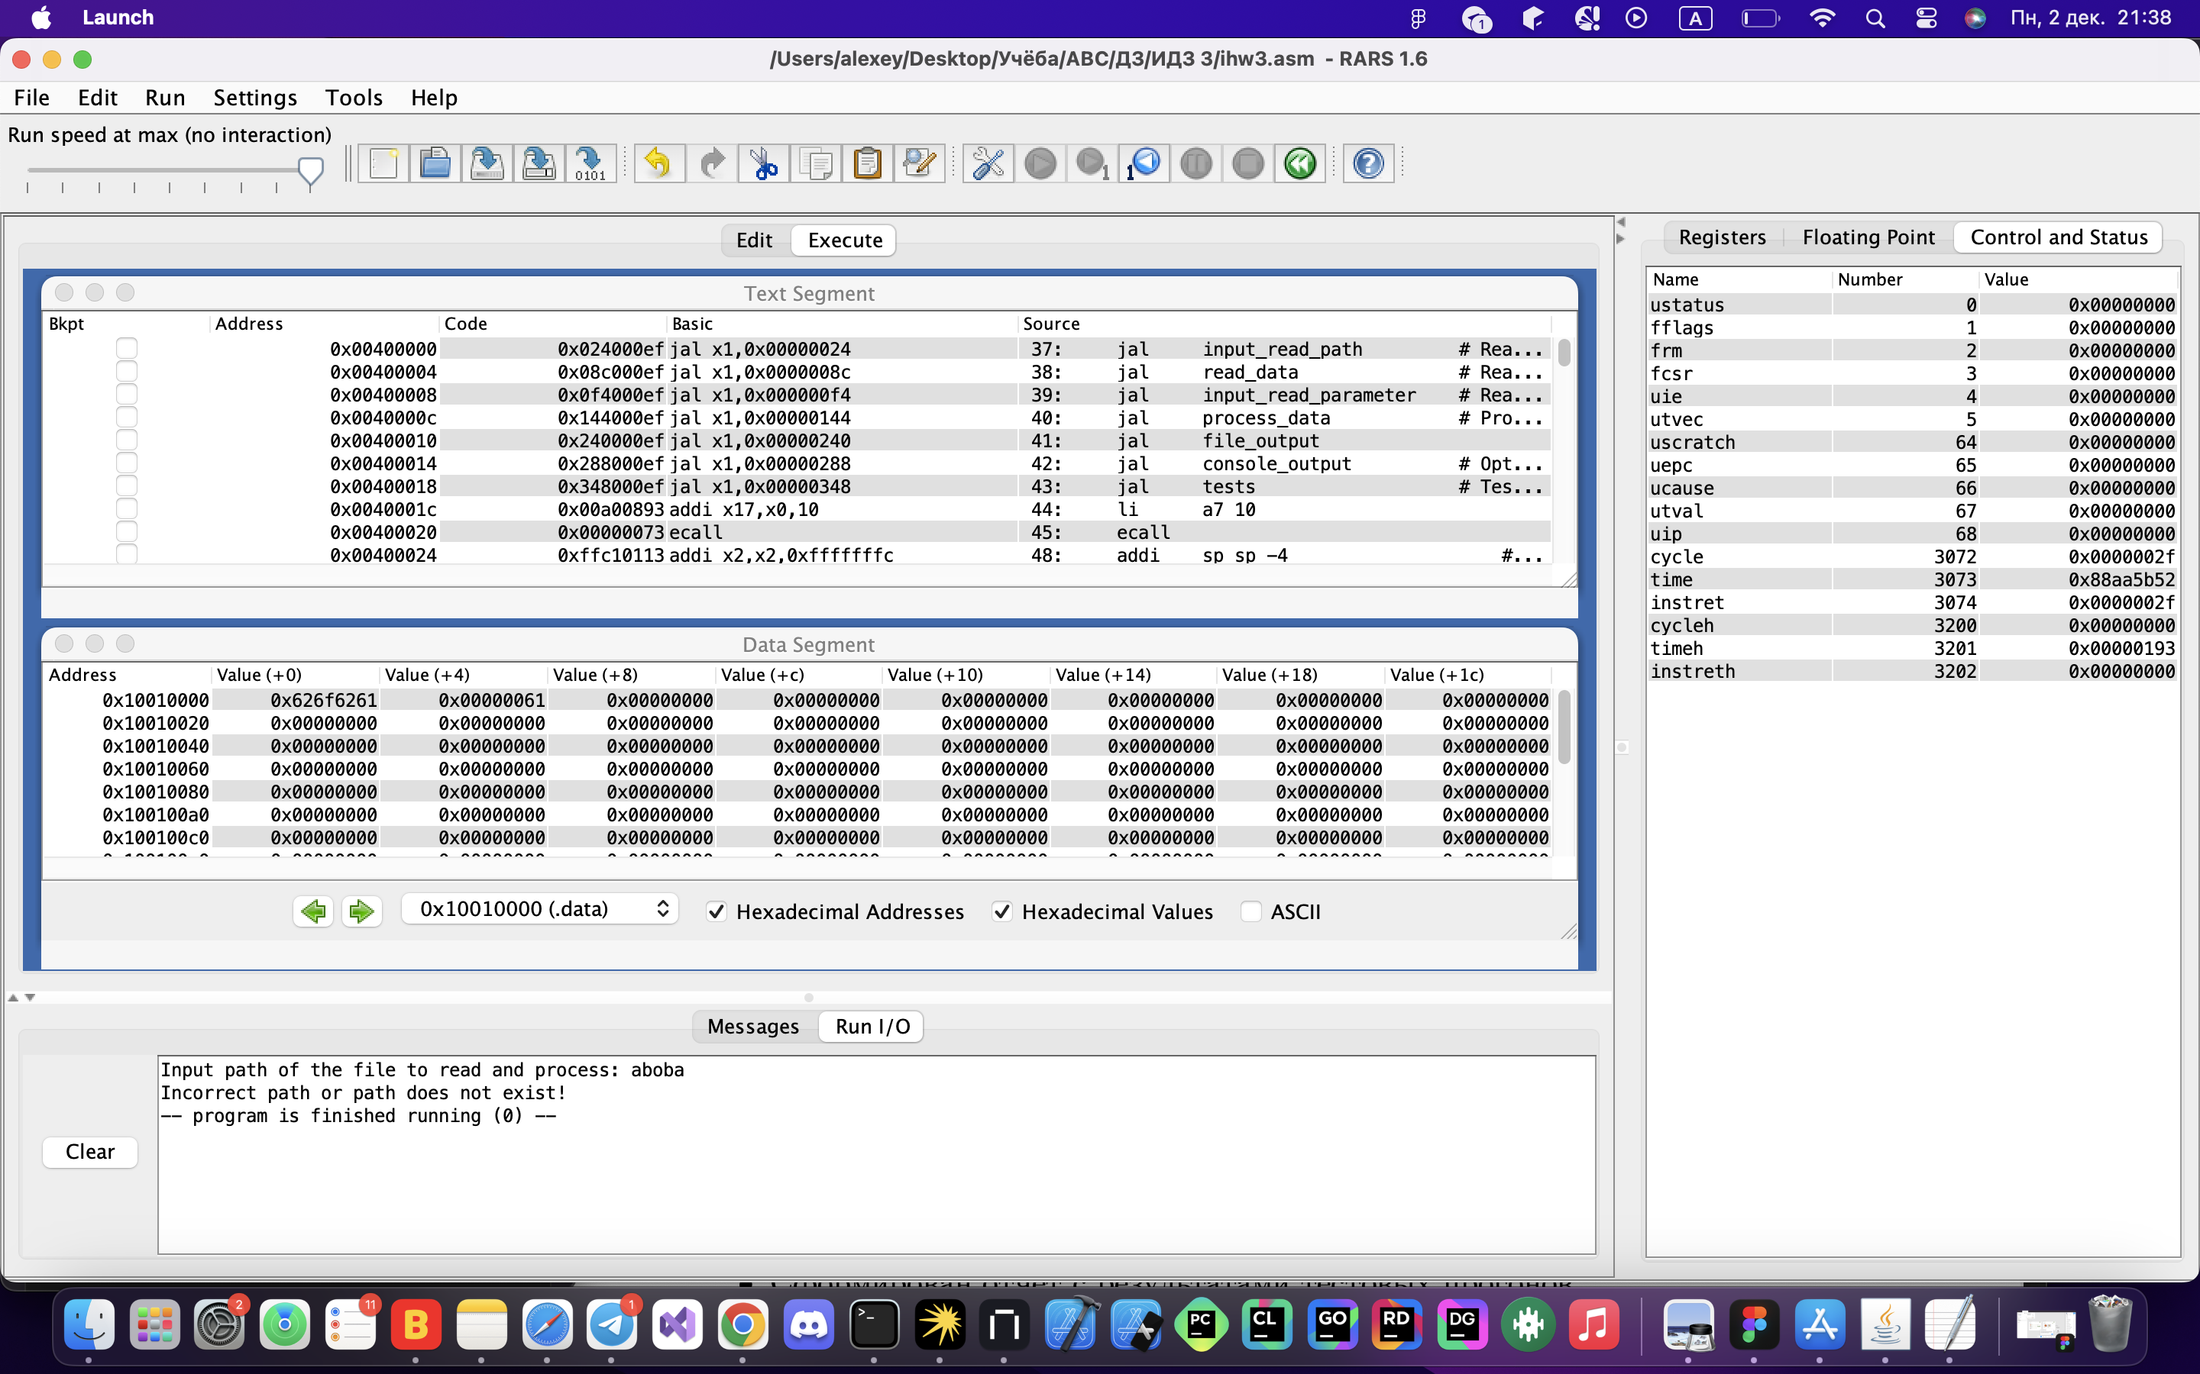  
  
Тест 2:  
Входные данные:  
Путь к test.txt  
Параметр для всех файлов: igla

Выходные данные:  
Result: 6 10

Tests:

test1.txt

Input substring: igla

Result: 6 10

test2.txt

Input substring: igla

Result: 27

test3.txt

Input substring: igla

Result: 0

test4.txt

Input substring: igla

Result: 43

test5.txt

Input substring: igla

Result:

test6.txt

Input substring: igla

Result:

-- program is finished running (0) --

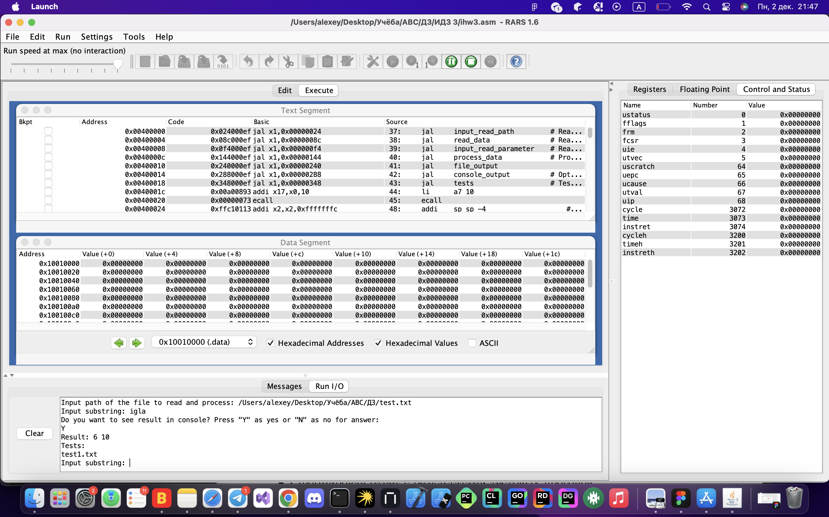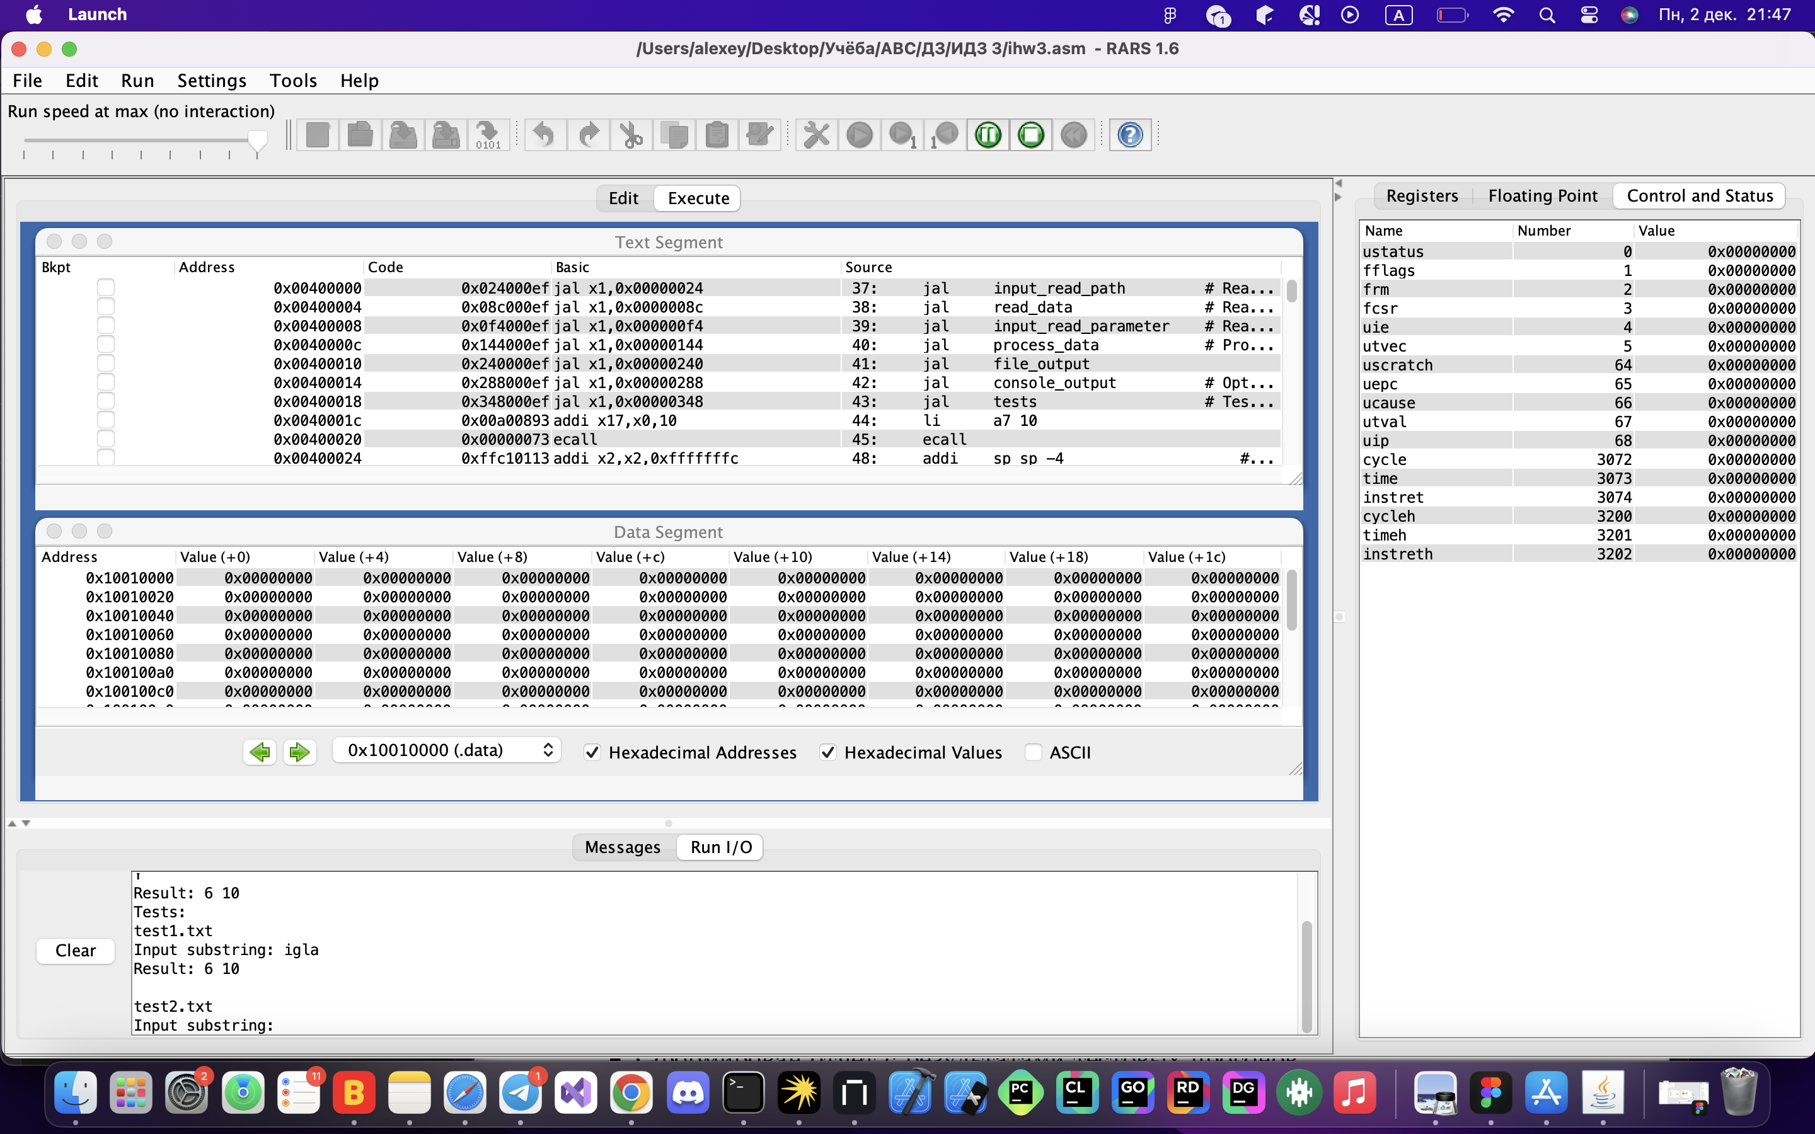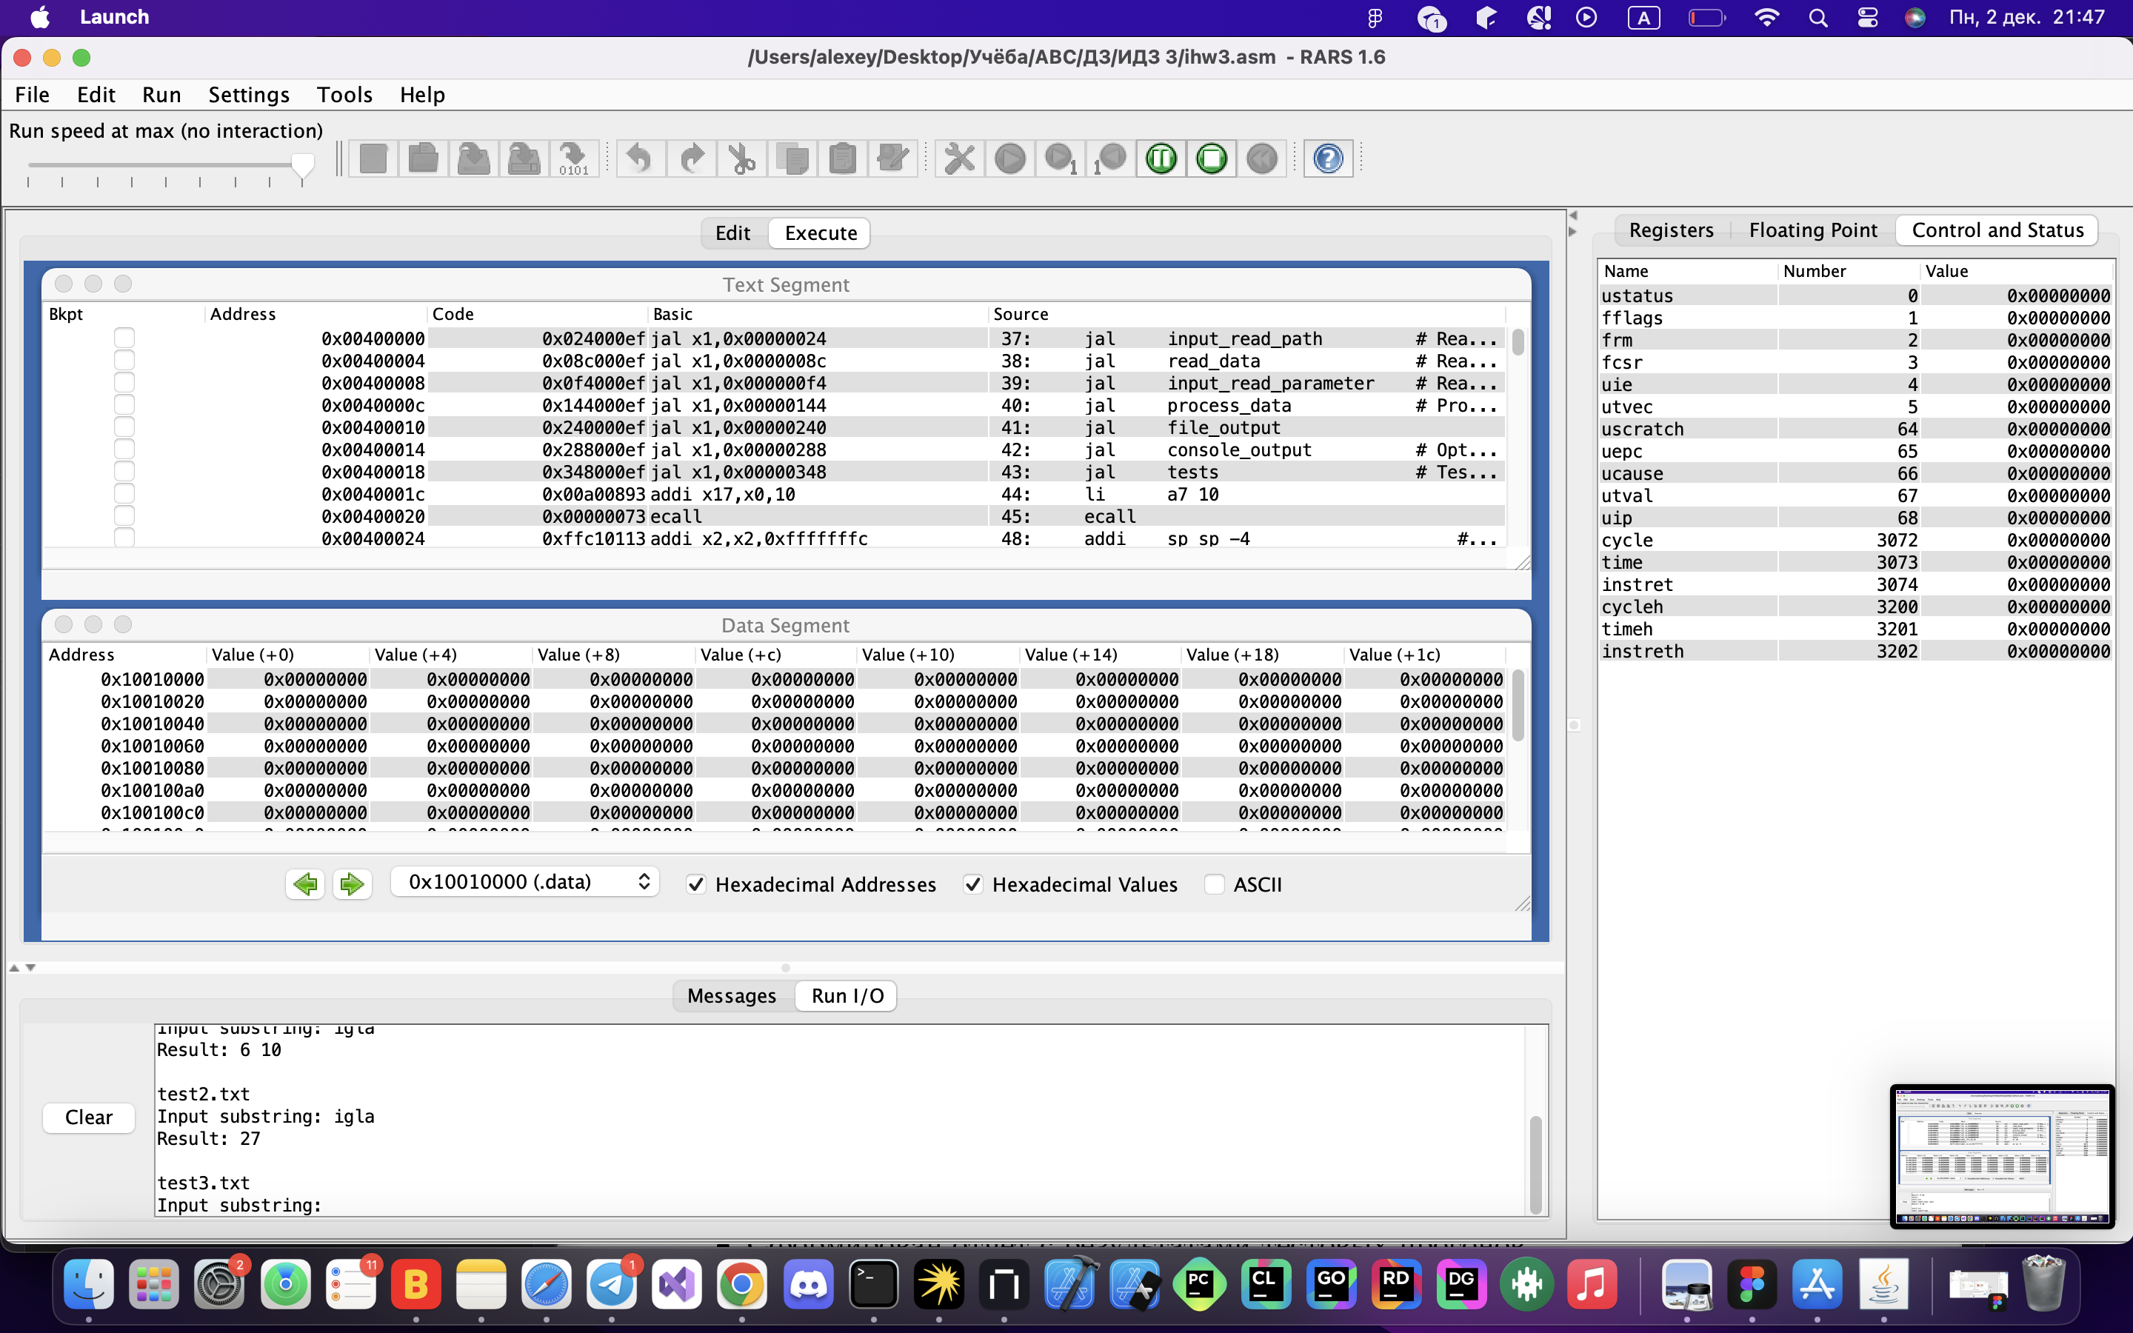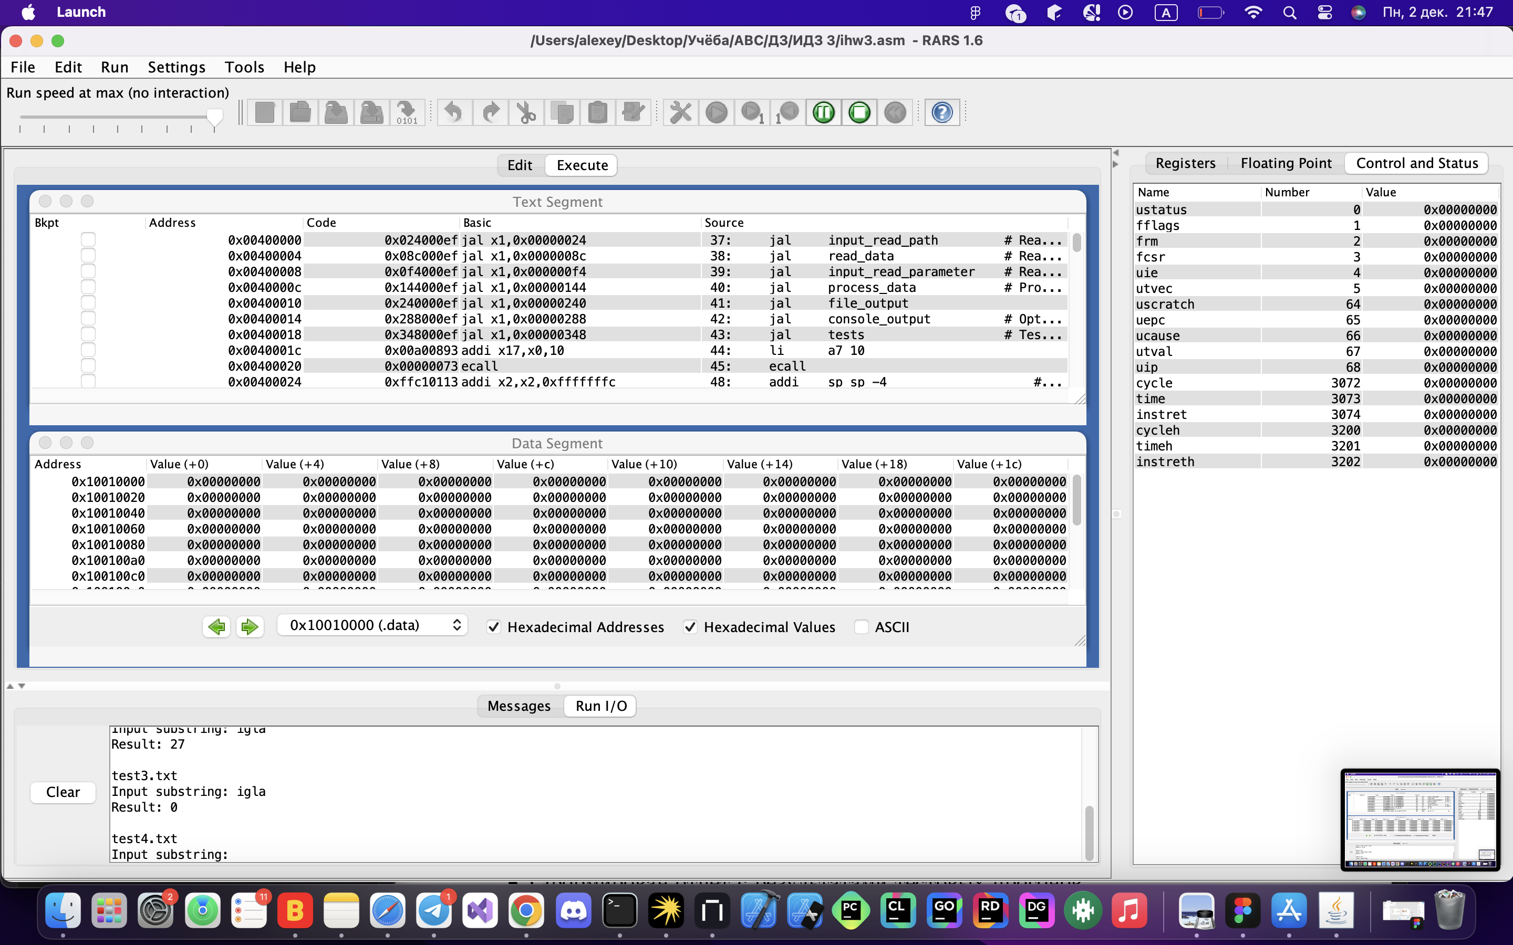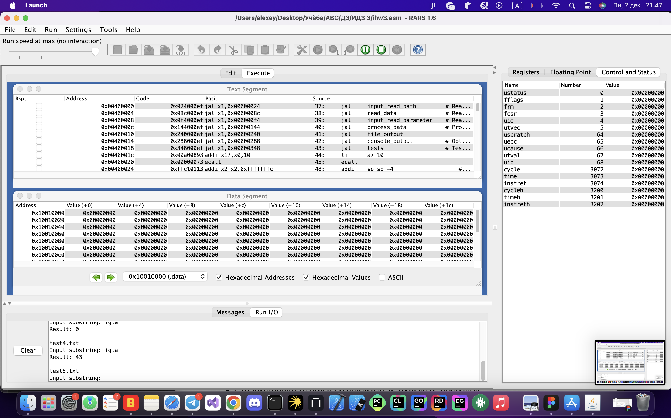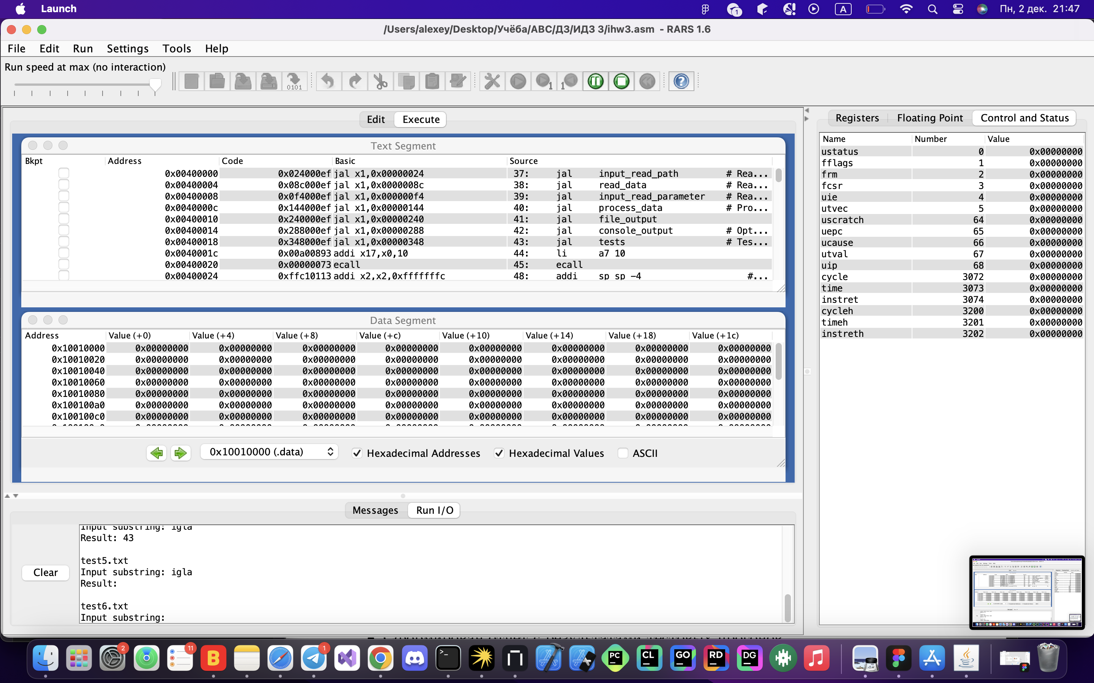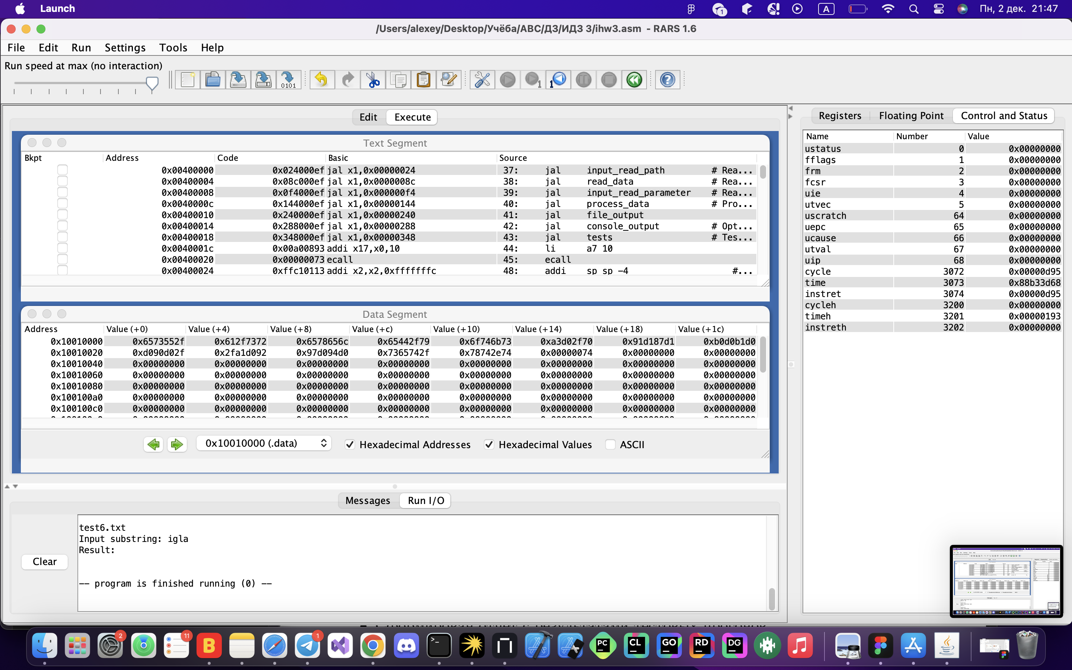  
В последних двух тестах результат пустой, так как в файле не присутствует заданная подстрока.  
  
Опциональный вывод в консоль осуществляется корректно. Это видно в тесте выше, а также на следующих скриншотах (ввели некорректные символы: o и newline, затем N как опция отказа):  
  
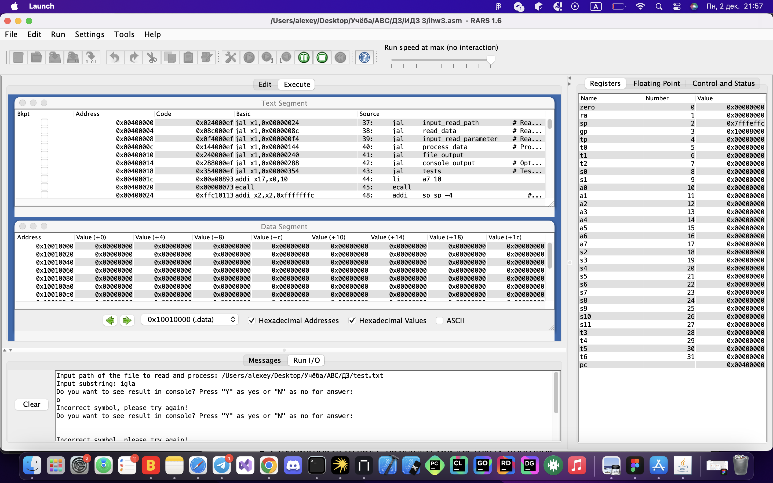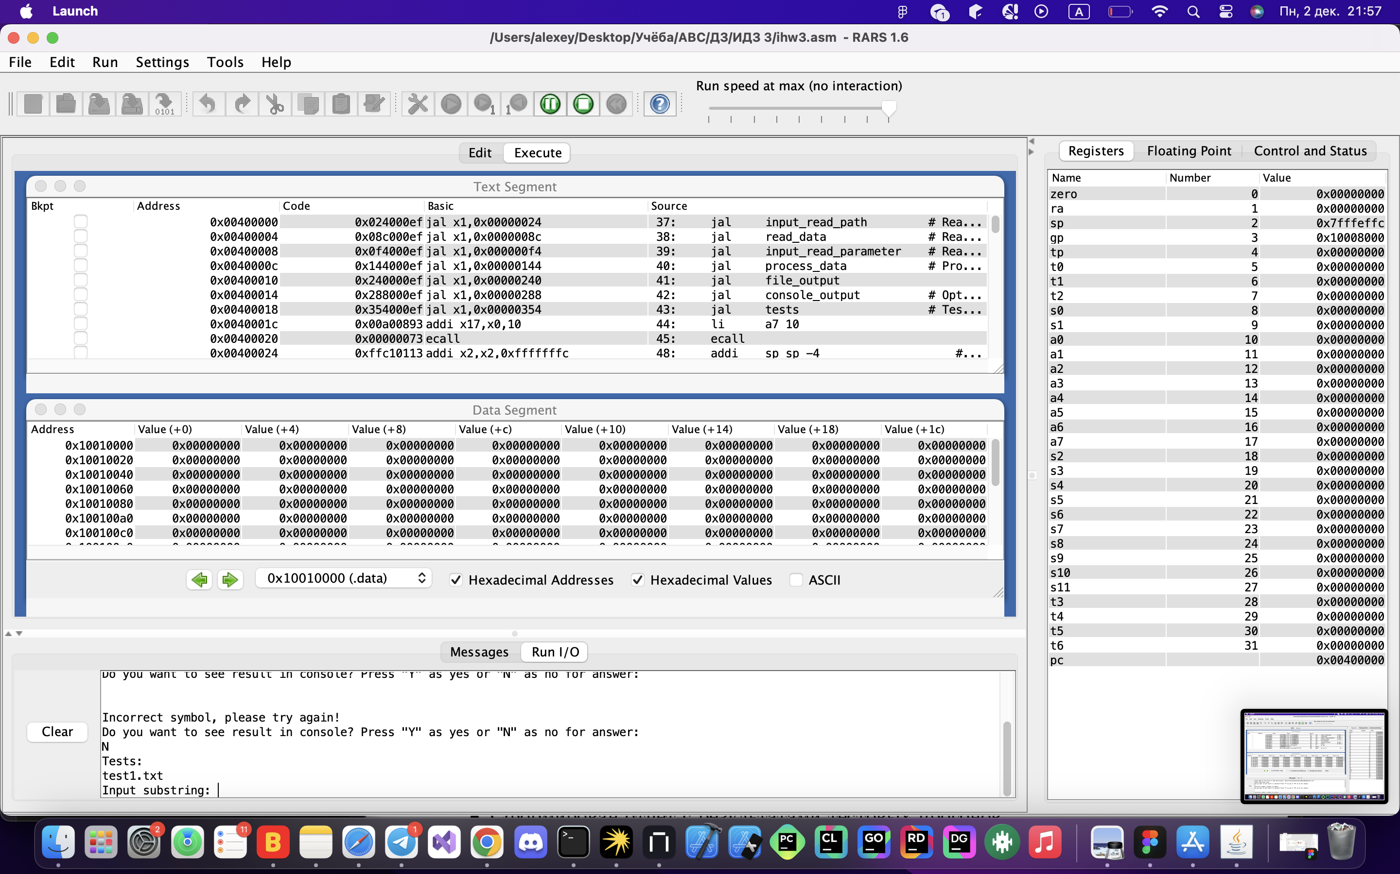

Критерий чтения буфера ограниченного размера в 512 байт и чтением файла 10 килобайт = 10240 байт в программе выполняется:  
Блок программы для данного критерия:  
read_data_buffer_loop:

li a7 63 # Reading data using 512 byte buffers from file descriptor

la a1 data_buffer # Loading address for buffer for data from file

li a2 DEFAULT_BUFFER_SIZE # Loading size of buffer in a2

ecall

addi a1 a1 DEFAULT_BUFFER_SIZE # Moving buffer address to the next 512 byte buffer

li t3 TEXT_BUFFER_SIZE # Maximum size of text = 10 kilobytes

sub t3 a1 t3

la a2 data_buffer # Loading starting address of buffer for data

blt a2 t3 close_file # Closing file, if there is no more data, error or 0 bytes were read

ble a0 zero close_file

j read_data_buffer_loop # Else, continue reading file

Текст программы (для удобства также расположен по [ссылке](https://github.com/0ne1ce/IHW3-Assembler)):  
**ihw3.asm:**  
.include "macros.asm"

.eqv DEFAULT_BUFFER_SIZE 512 # Buffer size for reding inputs and data from file

.eqv TEXT_BUFFER_SIZE 10240 # Maximum size of file

.data

path_buffer: .space DEFAULT_BUFFER_SIZE

data_buffer: .space TEXT_BUFFER_SIZE

param_buffer: .space DEFAULT_BUFFER_SIZE

output_text_buffer: .space TEXT_BUFFER_SIZE

input_path_message: .asciz "Input path of the file to read and process: "

error_path_message: .asciz "Incorrect path or path does not exist!"

error_reading_message: .asciz "Reading Error!"

input_param_message: .asciz "Input substring: "

output_result_message: .asciz "Result: "

option_message: .asciz "Do you want to see result in console? Press \"Y\" as yes or \"N\" as no for answer:\n"

error_option_message: .asciz "Incorrect symbol, please try again! "

output_path: .asciz "output.txt"

tests_message: .asciz "Tests:\n"

test1_path: .asciz "test1.txt"

test2_path: .asciz "test2.txt"

test3_path: .asciz "test3.txt"

test4_path: .asciz "test4.txt"

test5_path: .asciz "test5.txt"

test6_path: .asciz "test6.txt"

.text

.global main

main:

jal input_read_path # Reading and checking path for file to read from user

jal read_data # Reading data from file

jal input_read_parameter # Reading parameter from user

jal process_data # Processing data, searching and saving indexes for answer

jal file_output

jal console_output # Optional output in console

jal tests # Testing with other files in directory

li a7 10

ecall

input_read_path:

addi sp sp -4 # Saving return address

sw ra (sp)

read_input_path input_path_message, path_buffer, DEFAULT_BUFFER_SIZE # Reading input from user

li s1 -1 # Saving error code

beq s1 a0 error_path # If a0 = 0, then file does not exist or other error occured

mv t0 a0 # Saving the file decriptor in t0

lw ra (sp) # Remembering return address

addi sp sp 4

ret

read_data:

addi sp sp -8 # Saving return address

sw ra (sp)

sw s0 4(sp)

read_data_buffer_loop:

li a7 63 # Reading data using 512 byte buffers from file descriptor

la a1 data_buffer # Loading address for buffer for data from file

li a2 DEFAULT_BUFFER_SIZE # Loading size of buffer in a2

ecall

addi a1 a1 DEFAULT_BUFFER_SIZE # Moving buffer address to the next 512 byte buffer

li t3 TEXT_BUFFER_SIZE # Maximum size of text = 10 kilobytes

sub t3 a1 t3

la a2 data_buffer # Loading starting address of buffer for data

blt a2 t3 close_file # Closing file, if there is no more data, error or 0 bytes were read

ble a0 zero close_file

j read_data_buffer_loop # Else, continue reading file

close_file:

mv s0 a0 # s0 = size of data

add t1 a1 s0 # t1 = end of buffer for data

addi t1 t1 1

sb zero (t1) # Adding null terminator

li a7 57 # Closing file syscall

ecall

lw ra (sp) # Remembering return address

lw s0 4(sp)

addi sp sp 8

ret

input_read_parameter:

addi sp sp -4 # Saving return address

sw ra (sp)

read_input_substring input_param_message, param_buffer, DEFAULT_BUFFER_SIZE

lw ra (sp) # Remembering return address

addi sp sp 4

ret

process_data:

addi sp sp -20 # Moving position of stack for using s registers and saving ra for return

sw ra (sp)

sw s0 4(sp)

sw s1 8(sp)

sw s2 12(sp)

sw s3 16(sp)

la t0 data_buffer # Loading address of data buffer

la t1 param_buffer # Loading starting address of substring buffer

la t2 output_text_buffer # Loading starting address of output buffer

mv s0 zero # Current index of string in data

mv s1 zero # Index of occurrence

mv s2 zero # Bool, if there was a first occurrence for setting index in register s0 properly

li s3 0

process_loop:

lb t4 (t0) # Loading character from data

lb t5 (t1) # Loading character from substring

beq t4 zero process_loop_end # Ending loop if it is the end of data string

beq t4 t5 equal_characters # If characters equal, branch

mv s2 zero # Resetting index of first occurrence

la t1 param_buffer # Reseting starting address of substring buffer

addi s0 s0 1

addi t0 t0 1 # Moving data characters buffer on next position

j process_loop

equal_characters:

beqz s2 set_first_occurence

j continue_matching

set_first_occurence:

li s2 1

mv s1 s0

continue_matching:

addi s0 s0 1 # Moving index of string data

addi t0 t0 1 # Moving to next character in data

addi t1 t1 1 # Moving to next character in substring

lb t5 (t1) # Loading character from substring

beq t5 zero end_of_substring # If it is newline, then it is the end of substring and we need to save index of occurrence

lb t4 (t0) # Loading character from data

beq t4 zero process_loop_end # End of data

beq t4 t5 continue_matching # If equal characters, continue

mv s2 zero # Reseting flag

la t1 param_buffer # Reseting pointer of substring buffer

addi s0 s0 1 # Increasing index and position in data buffer

addi t0 t0 1

j process_loop

end_of_substring:

mv a0 s1 # Number to convert

mv a1 t2 # Pointer on output buffer

jal int_to_str

mv t2 a1 # Pointer update

li t3 32 # ASCII for space ' '

sb t3 (t2)

addi t2 t2 1

mv s2 zero # Resetting flag of first occurrence

la t1 param_buffer # Resetting starting address of substring buffer

j process_loop

process_loop_end:

li s3 0 # Adding null terminator

sb s3 (t2)

end_process:

lw ra (sp) # Resetting s registers to сomply with the сonventions

lw s0 4(sp)

lw s1 8(sp)

lw s2 12(sp)

lw s3 16(sp)

addi sp sp 20

ret

file_output:

addi sp sp -4

sw ra (sp)

la a0 output_path # Address of the output path

li a7 1024 # Syscall for opening a file

li a1 1 # Loading 1 as a mode for writing

ecall

mv s0 a0 # Saving file descriptor

li a7 64 # Syscall for writing into a file

mv a0 s0

la a1 output_text_buffer # Address of the output buffer

li a2 DEFAULT_BUFFER_SIZE # Size of the buffer

ecall

li a7 57 # Syscall for closing a file

ecall

lw ra (sp)

addi sp sp 4

ret

console_output:

addi sp sp -4 # Saving return address

sw ra (sp)

la a0 option_message # Loading mesage to offer user an optional output

li a7 4

ecall

la a0 param_buffer # Address to store option input

li a1 2 # Size of reading only one character from console, 2 = 1 character + 1 "\n"

li a7 8 # Syscall for reading input from user

ecall

li t3, 'Y' # ASCII code for 'Y'

li t4, 'N' # ASCII code for 'N'

la t0 param_buffer # Address of the input buffer

lb t1 (t0) # Load the first character

beq t1 t3 print # If input is 'Y', print result in console

beq t1 t4 console_output_end # If input is 'N', branch to end

li a0 10 # Printing newline in console

li a7 11

ecall

la a0 error_option_message # Error message, letting user to try again

li a7 4 # Syscall for writing to stdout

ecall

li a0 10 # Printing newline in console

li a7 11

ecall

j console_output

print:

li a0 10 # Printing newline in console

li a7 11

ecall

la a0 output_result_message # Result message

li a7 4

ecall

la a0 output_text_buffer # Loading address and printing data of the output buffer

li a7 4

ecall

li a0 10 # Printing newline in console

li a7 11

ecall

lw ra (sp) # Remembering return address

addi sp sp 4

ret

console_output_end:

lw ra (sp) # Remembering return address

addi sp sp 4

li a0 10 # Printing newline in console

li a7 11

ecall

ret

tests:

addi sp sp -4

sw ra (sp)

la a0 tests_message # Load message that shows a start of tests

li a7 4

ecall

la a0 test1_path # Test 1

li a7 4

ecall

li a0 10 # Printing newline in console

li a7 11

ecall

la a0 test1_path

jal test # Testing process for test file

la a0 test2_path # Test 2

li a7 4

ecall

li a0 10 # Printing newline in console

li a7 11

ecall

la a0 test2_path

jal test # Testing process for test file

la a0 test3_path # Test 3

li a7 4

ecall

li a0 10 # Printing newline in console

li a7 11

ecall

la a0 test3_path

jal test # Testing process for test file

la a0 test4_path # Test 4

li a7 4

ecall

li a0 10 # Printing newline in console

li a7 11

ecall

la a0 test4_path

jal test # Testing process for test file

la a0 test5_path # Test 5

li a7 4

ecall

li a0 10 # Printing newline in console

li a7 11

ecall

la a0 test5_path

jal test # Testing process for test file

la a0 test6_path # Test 6

li a7 4

ecall

li a0 10 # Printing newline in console

li a7 11

ecall

la a0 test6_path

jal test # Testing process for test file

lw ra (sp) # Remembering return address

addi sp sp 4

ret

test:

addi sp sp -4 # Saving return address

sw ra (sp)

la t0 data_buffer # Loading and clearing data_buffer

clear_data_buffer_loop:

lb t1 (t0) # Loading current character

beq t1 zero clear_param_buffer_loop_prep # If null terminator, then end clearing

sb zero (t0) # Clearing current position

addi t0 t0 1 # Moving pointer to the next position

j clear_data_buffer_loop

clear_param_buffer_loop_prep:

la t0 output_text_buffer # Loading and clearing param_buffer

clear_param_buffer_loop:

lb t1 (t0) # Loading current character

beq t1 zero process_test # If null terminator, then end clearing

sb zero (t0) # Clearing current position

addi t0 t0 1 # Moving pointer to the next position

j clear_param_buffer_loop

process_test:

li a7 1024 # Reading a file from path with syscall

li a1 0 # Enabling reading mode with 0 in a1 register

ecall

li s1 -1 # Saving error code

beq s1 a0 error_path # If a0 = 0, then file does not exist or other error occured

jal read_data # Reading data from test file

jal input_read_parameter # Input parameter as substring to find in console

jal process_data # Processing data

jal test_console_output # Output result in console (without option)

lw ra (sp) # Remembering return address

addi sp sp 4

ret

test_console_output:

addi sp sp -4 # Saving return address

sw ra (sp)

la a0 output_result_message # Result message

li a7 4

ecall

la a0 output_text_buffer # Loading address and printing data of the output buffer

li a7 4

ecall

li a0 10 # Printing newline in console

li a7 11

ecall

li a0 10 # Printing newline in console

li a7 11

ecall

lw ra (sp) # Remembering return address

addi sp sp 4

ret

# Input: a0 = number to convert from int to str, a1 = address of buffer for string

# Output: a1 = updated address of buffer after saving a string

int_to_str:

addi sp sp -28 # Moving position of stack for using s registers and saving ra for return

sw ra (sp)

sw s0 4(sp)

sw s1 8(sp)

sw s2 12(sp)

sw s3 16(sp)

sw s4 20(sp)

sw s5 24(sp)

mv s0 a0 # Number to convert from int to str in s0 register

mv s1 a1 # s1 is pointer on output buffer for current number

addi s2 s1 16 # s2 is temporary buffer with size of maximum 16 digits

li s3 10

beqz s0 int_zero # If number to convert is zero, then converting it in int_zero

convert_loop: # While s0 is not equal zero

rem s4 s0 s3 # s4 is a last digit of current number: s4 = s0 % 10

addi s4 s4 48 # Converting digit into ASCII by adding 48

addi s2 s2 -1 # Moving position backwards in temporary buffer

sb s4 (s2) # Storing character in buffer

div s0 s0 s3 # Removing last digit by dividing: s0 = s0 / 10

bnez s0 convert_loop

copy_loop:

lb s4 (s2) # Loading character from temporary buffer

sb s4 (s1) # Saving it in output buffer

sb zero (s2) # Reseting memory to zero in temporary buffer in current position to reuse it in tests

addi s2 s2 1 # Moving position in temporary buffer

addi s1 s1 1 # Moving position in output buffer

lb s5 (s2) # Checking if it is the end of temporary buffer

bnez s5 copy_loop # If it is not, continue

j int_to_str_end

int_zero:

li s4 48 # ASCII code for '0'

sb s4 (s1) # Stroring '0' into buffer

addi s1 s1 1 # Moving buffer's pointer

j int_to_str_end

int_to_str_end:

mv a1 s1 # Return a1

lw ra (sp) # Resetting s registers to сomply with the сonventions

lw s0 4(sp)

lw s1 8(sp)

lw s2 12(sp)

lw s3 16(sp)

lw s4 20(sp)

lw s5 24(sp)

addi sp sp 28

ret

error_path:

li a7 4 # Output message for error

la a0 error_path_message

ecall

li a7 10 # Syscall finishing a program

Ecall

**macros.asm:**

.macro read_input_path %message, %buffer, %buffer_size

la a0 %message # Loading message for user

li a7 4

ecall

la a0 %buffer # Buffer for saving a path

li a1 %buffer_size # Size of buffer with path

li a7 8 # Reading string input with file path from user

ecall

li t0 '\n' # Loading newline symbol

mv t1 a0 # Saving address of buffer in t1

reading_loop:

lb t2 (t1) # Loading current character

beq t2 t0 replace_newline # If character is newline, replace it

addi t1 t1 1 # Moving to next character

j reading_loop

replace_newline:

sb zero (t1) # Replacing newline with a null terminator

li a7 1024 # Reading a file from path with syscall

li a1 0 # Enabling reading mode with 0 in a1 register

ecall

.end_macro

.macro read_input_substring %message, %buffer, %buffer_size

la a0 %message # Loading message for user

li a7 4

ecall

la a0 %buffer # Buffer for saving a path

li a1 %buffer_size # Size of buffer with path

li a7 8 # Reading string input with file path from user

ecall

li t0 '\n' # Loading newline symbol

mv t1 a0 # Saving address of buffer in t1

reading_loop:

lb t2 (t1) # Loading current character

beq t2 t0 replace_newline # If character is newline, end reading

addi t1 t1 1 # Moving to next character

j reading_loop

replace_newline:

sb zero (t1) # Replacing newline with a null terminator

.end_macro